***Project: Analysis of Guardians Pvt Ltd Sales***

**Overview:**

The Guardian Pvt Ltd Sales Dashboard is a comprehensive data analysis and visualization project that focuses on tracking and visualizing sales data for Guardian Pvt Ltd. The project is built using MySQL Workbench 8.0 for data management and Power BI for creating interactive and insightful dashboards.

**Components:**

*1. Data Collection and Storage*

- MySQL Database: Utilized MySQL Workbench 8.0 to create and manage a relational database for storing sales data.

- Tables: Designed and structured tables to store information about transactions, dates, and market codes.

*2. Data Integration and Cleaning*

- Imported Data: Extracted data from various sources and loaded it into the MySQL database.

- Data Transformation: Performed data cleaning, transformation, and normalization to ensure data accuracy and consistency.

3. *SQL Queries*

- Created SQL queries to retrieve specific data subsets for analysis.

- Aggregation: Utilized SQL queries to calculate metrics such as total sales amount, average sales, etc.

- Join Operations: Combined data from different tables using JOIN operations to enrich the dataset.

4. *Power BI Dashboard*

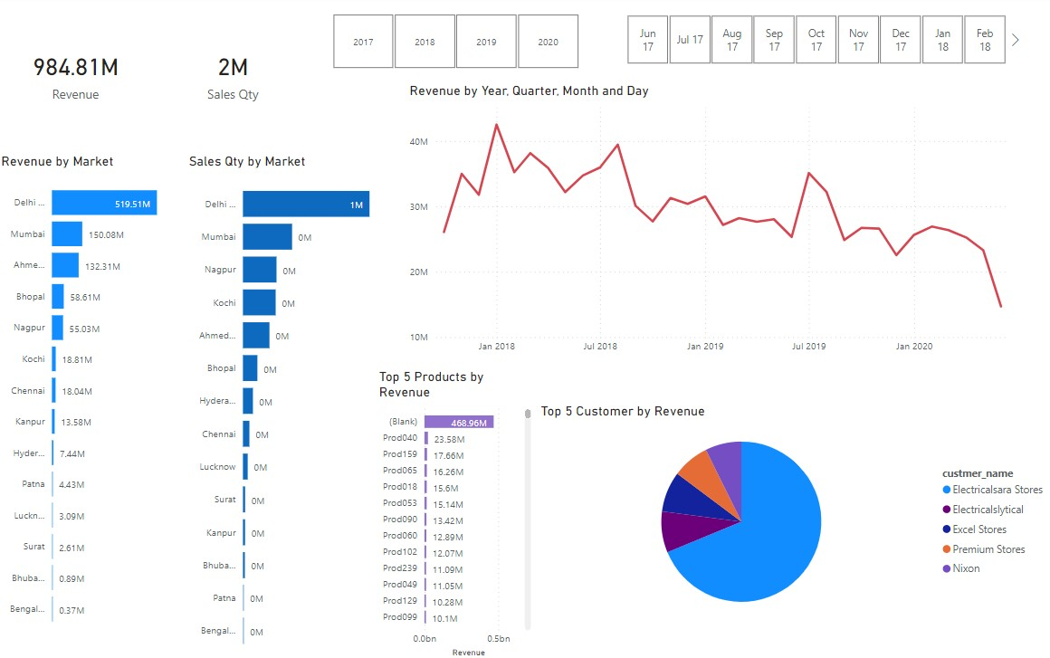

- Data Connection: Connected Power BI to the MySQL database to fetch and refresh data.

- Visualizations: Designed interactive visualizations, including charts, graphs, and tables, to represent sales trends and performance.

- Drill-Down: Implemented drill-down functionality to allow users to explore data at various levels of granularity.

5. *Dashboard Features*

- Sales Overview: Provided an overview of total sales, sales by market, and sales by year.

- Geographical Analysis: Visualized sales data on a map to identify key markets and regions.

- Trend Analysis: Displayed sales trends over time, highlighting seasonal variations and growth patterns.

- Product Performance: Analyzed sales performance for different products and categories.

- User Interactivity: Enabled users to filter data, view specific details, and interact with the dashboard elements.

6*. Insights and Decision-Making*

- Decision Support: Equipped decision-makers with actionable insights into sales performance.

- Performance Evaluation: Assisted in identifying best-performing markets, products, and time periods.

- Strategy Formulation: Supported data-driven strategic planning and marketing efforts.

**Benefits:**

- Comprehensive Visualization: The dashboard provides an intuitive and consolidated view of sales data, making it easier to identify trends and patterns.

- Data-Driven Decisions: Enables informed decision-making by presenting key metrics and insights in a visually appealing format.

- Efficiency and Accuracy: Reduces manual data analysis efforts and minimizes errors through automated data processing.

- Interactive Exploration: Users can explore data dynamically and derive insights by applying filters and interacting with visualizations.

**Conclusion:**

The Guardian Pvt Ltd Sales Dashboard project demonstrates the effective utilization of MySQL Workbench 8.0 and Power BI to create a powerful tool for analyzing and visualizing sales data. The dashboard empowers stakeholders to make data-driven decisions and steer the company's sales strategy towards success.